Name
Course
Date
Financial Management
QUESTION 1
- .Use “PMI” function of spreadsheet to calculate montly payment on the basic of 20 years ( 240 months) a mortization period.
Put values and formulae in the spreadsheet as shown in the image below:
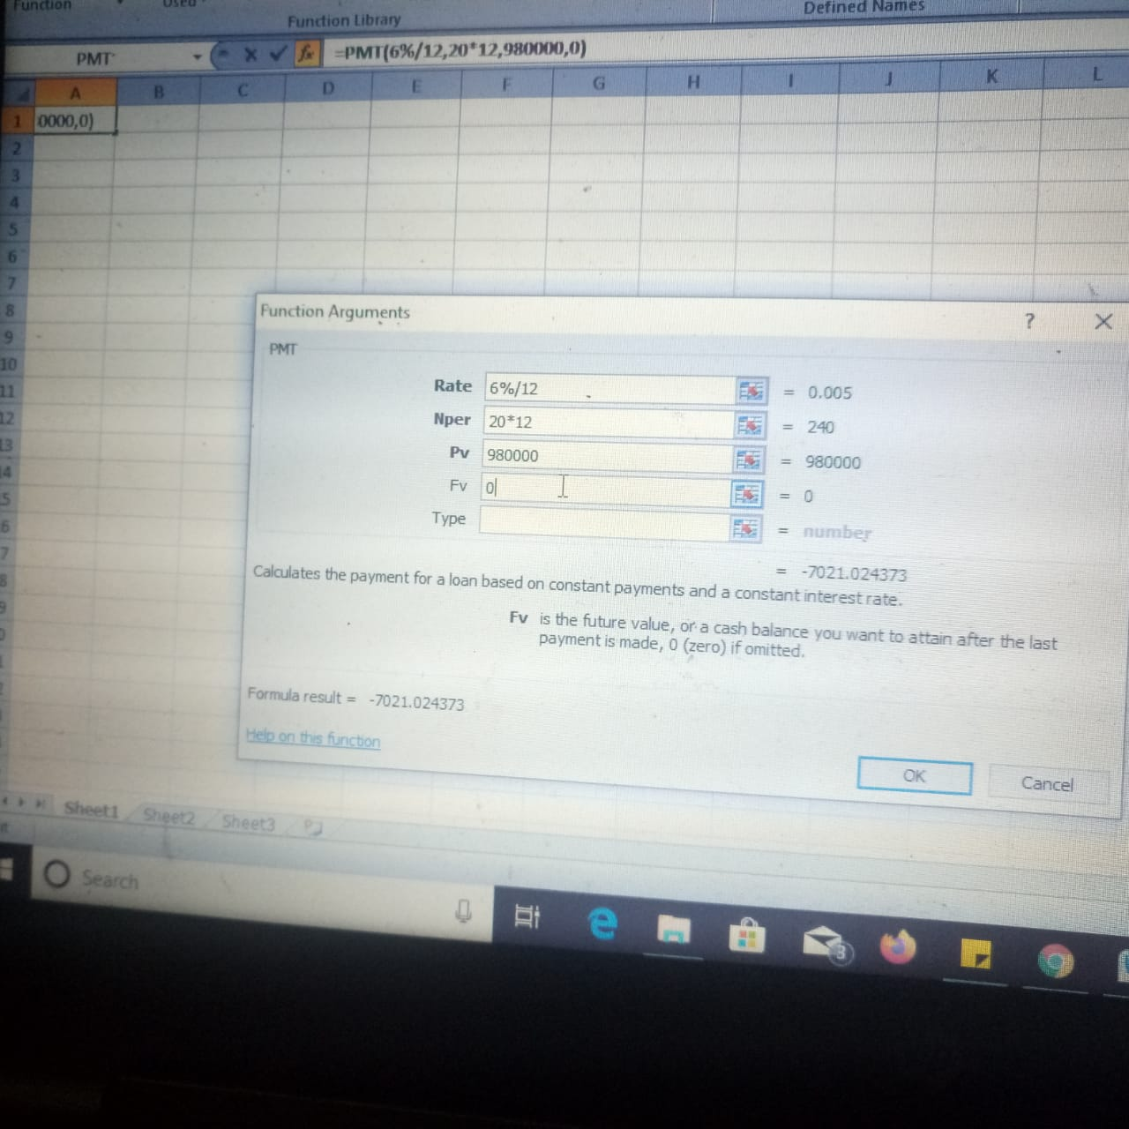
The obtained results after putting the values and “PMT” Function in spreadsheet will be the following:
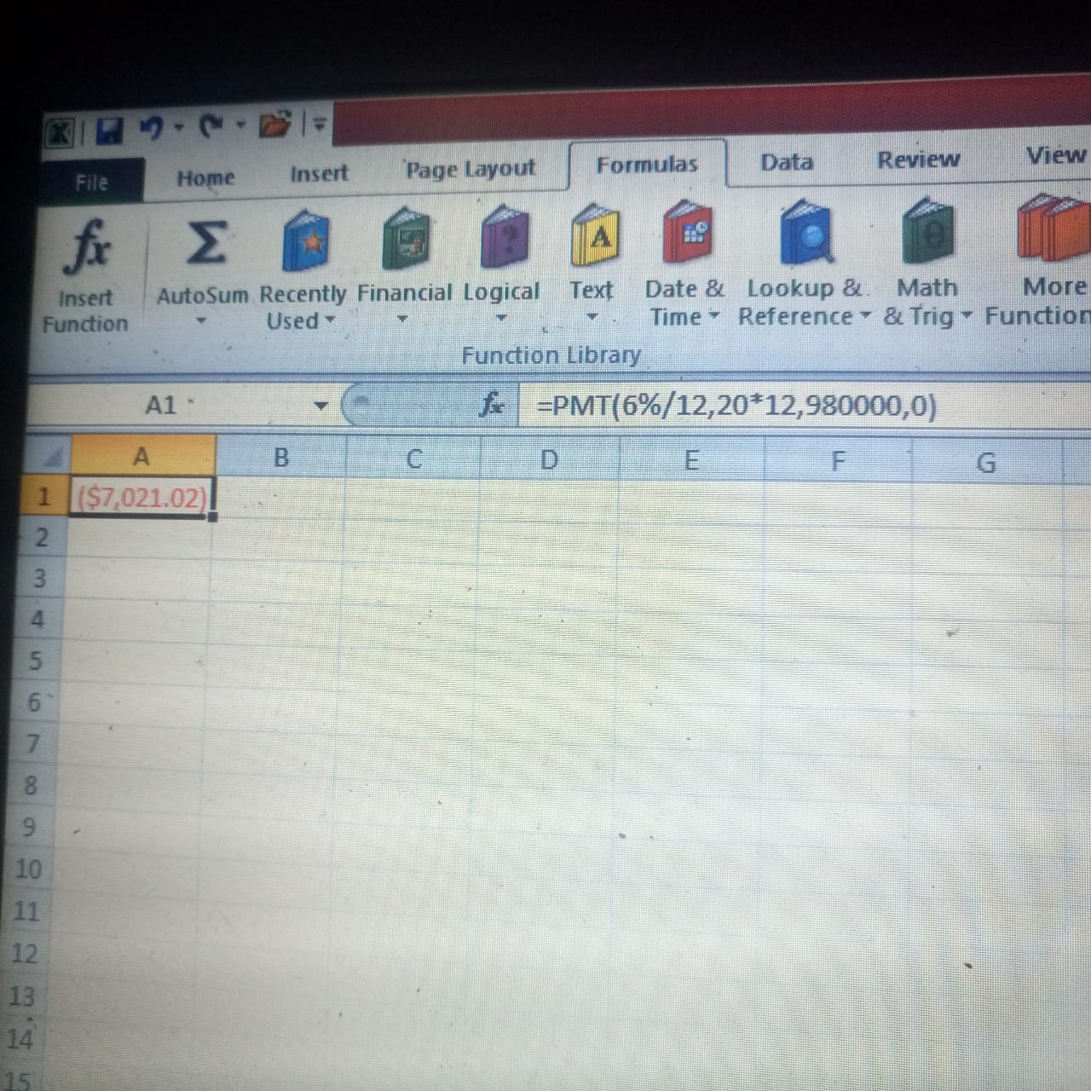
Thus Initial monthly payment on his Mortgage is $ 7021.02
- Use “PV” function of spread sheet to calculate loan balance after 5 years,here the amortization period will reduce by 60 months.
Put Values and formulae in spreadsheet as shown in Image below:
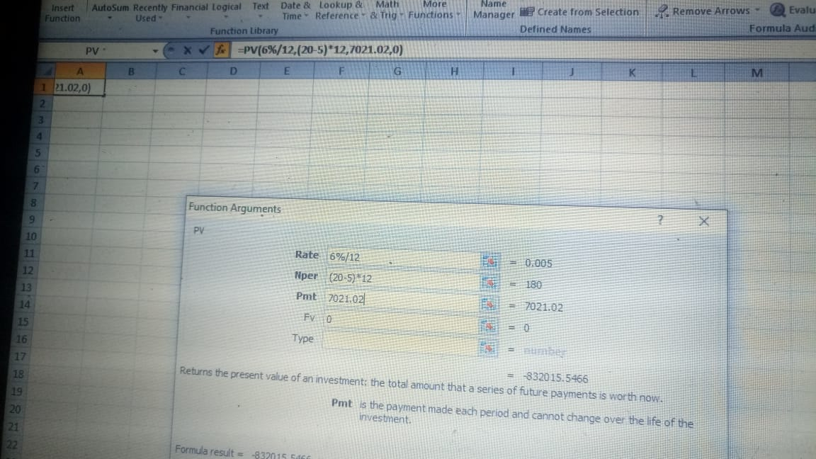

The obtained results after putting the values and “PV” function in spreadsheet will be the following:
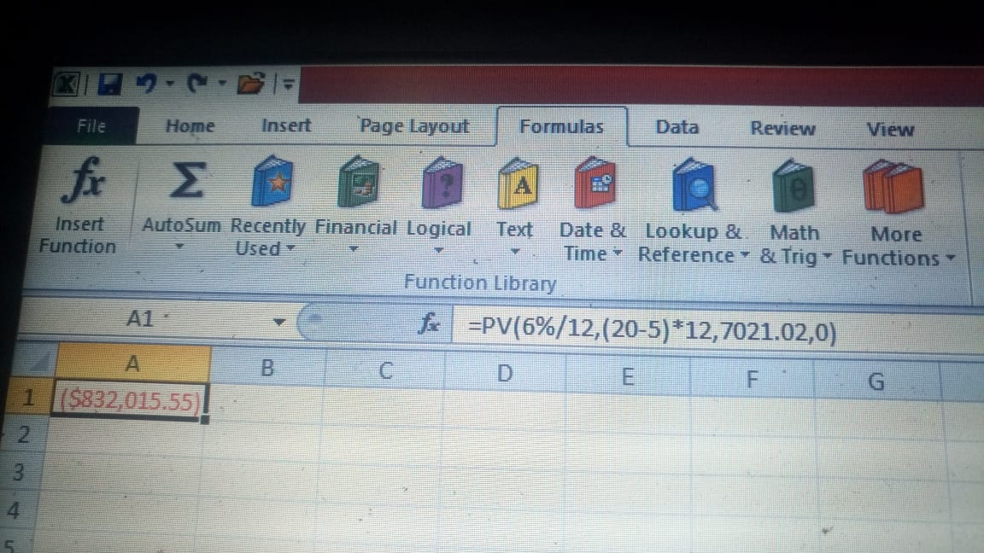
Thus, the outstanding principal on his Mortgage is : $ 832,015.55
- Use “PMT” Function of spreadsheet to calculate monthly payment on the basis of 15 years (180 months) a mortization period.
Put values and formulae in spreadsheet as shown in the image below:
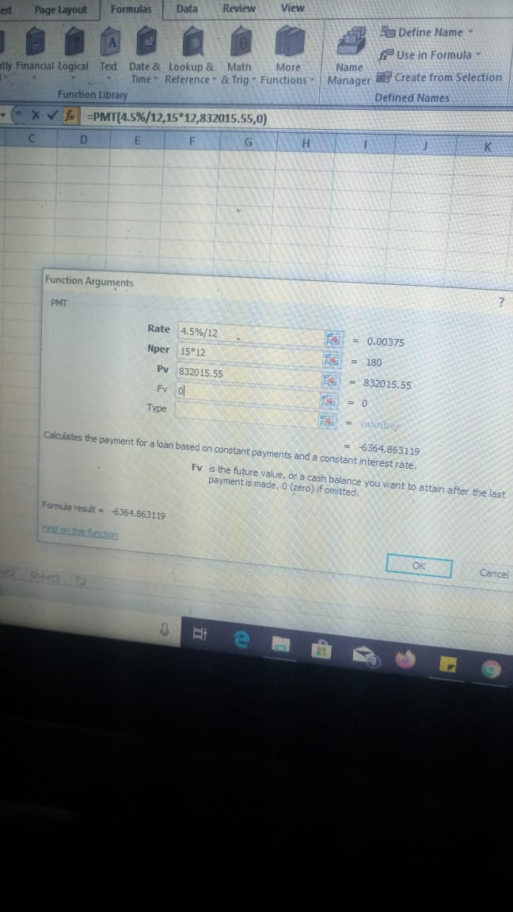
The obtained results after the values and “PMT” Function in spreadsheet will be the following:
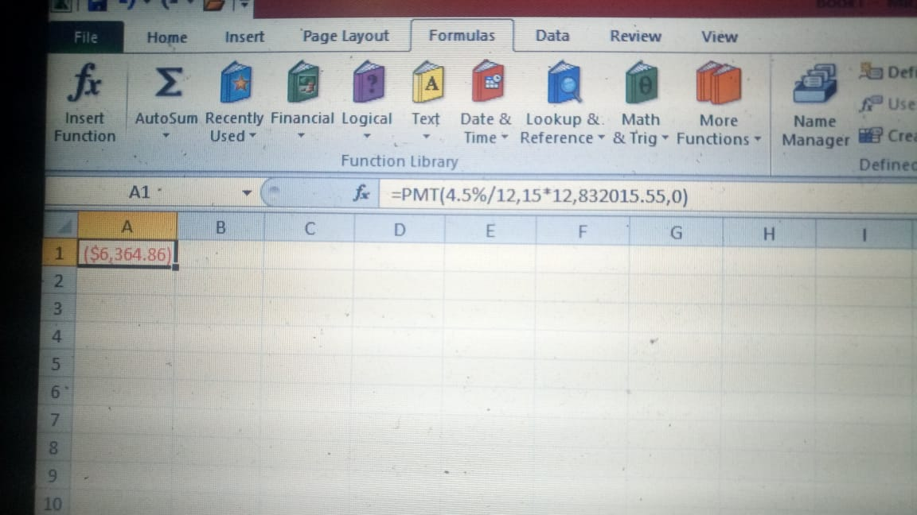

Thus, monthly payment on new rate of interest is: $6364.86

QUESTION 2
In order to calculate how much will Jennifer have after 3 years,
we will first calculate the future value of $5,000 after 3 years
P(1+r/n)^{n*t}
where P = Principal amount, r= rate of interest, n= number of installments, t= number of years
5000*(1+ 0.015/12)^{12*3}
=$5000(1.00125)³⁶
=$5000*1.046
=$5,229.99
Now we will calculate future value of the payments
d*[(1+i)^{n*t} -1/i *(1+i),
where d = monthly deposit, i = rate/number of instalments in a year
$500*[(1+0.00125)³⁶-1/0.00125*(1+.00125)]
$500*(1.046-1)/0.00125*1.00125
18,423
The total value Jennifer will have after 3 years is the total of $5,229.99+ $18,423
$ 23,652.99

QUESTION 3
SOLUTION:
The KJ Corporation has averaged an ROE of |  |  |  |  |  |  | 14% | over
the past 5 years and that should continue into the
future. The firm has a payout ratio of |  |  |  |  |  |  | 67% | on
earnings per share of |  |  |  | $3.94 | and paid the dividend
yesterday. The discount rate for a firm of KJ's
risk level is |  |  | 15%
a) | What is the expected Growth Rate of KJ's dividend?
b) | What is KJ's current stock price?

a) Dividend growth rate = ROE*(1-dividend payout ratio)
ROE = |  | 14%
Payout ratio = |  | 67%
Dividend growth rate = 14%*(1-67%)
 |  | 4.62%
b) we can use the dividend discount model to compute the share price
price = expected dividend/(required rate - growth rate)
Expected dividend = |  |  | =3.94*67%*104.62%
 |  |  | 2.76
price = 2.76/(15%-4.62%)
 |  |  | 61.74

QUESTION 4
SOLUTION.
YTM on the bond= 240 basis points above YTM of similar govt. bond
One basis point = 0.01%
so, 250 basis points= 240*0.01%= 0.024 or 2.4%
So, YTM on JG's bond = 2.4%+2.4%= 4.8%
Coupon rate should JG choose if it wants the bonds to sell at par= 4.8%
as when Price=Par, Coupon Rate= YTM= 4.8%
b. $ Amt. of capital they will raise from the sale=
1500*$ 1000=
1500000
c.2 years later--
YTM=2.8%+2.4%=5.2%
Price of the bond=(Copuon pmt.*(1-(1+r)^-n)/r)+(FV/(1+r)^n)
ie. ((1000*4.8%)*(1-1.05^-8)/0.05))+(1000/1.05^8)=
((1000*4.8%)*(1-1.05^-8)/0.05))+(1000/1.05^8)
987.074
d..JG's bonds now sell at a
PREMIUM
YTM< Coupon Rate
Price> Par
QUESTION 5
a) Let's first start by forming a payment schedule for each of Richard's kids for there respecive 4 years of university, payable in September of the respective years. The oldest of his kids, the 14 year old son, begins college in 2023.
This will help us in understanding the total cash outlfow on tuitions for each year.
Year | Child 1 | Child 2 | Child 3 | Child 4 | Total (in $)
2023 | 5,144 | - | - | - | 5,144
2024 | 5,144 | 5,144 | - | - | 10,288
2025 | 5,144 | 5,144 | - | - | 10,288
2026 | 5,144 | 5,144 | 5,144 | 5,144 | 20,576
2027 | - | 5,144 | 5,144 | 5,144 | 15,432
2028 | - |  | 5,144 | 5,144 | 10,288
2029 | - |  | 5,144 | 5,144 | 10,288
The formula for Monthly Annuity is,
where, r = monthly interest rate = annual rate / 12 = 0.03/12 = 0.0025
n = number of months = Number of years * 12
Hence,
Therefore, by substituting the total cash outflow required for each year we get the monthly savings to be made for the cash flow of the repsective year. This can be shown in the table below
Year | Total Cash Flow | Value for 'n+1' | Required Monthly savings
2023 | 5,144 | (4 * 12) + 1 = 49 | 100.75
2024 | 10,288 | (5 * 12) + 1 = 61 | 158.75
2025 | 10,288 | (6 * 12) + 1 = 73 | 130.27
2026 | 20,576 | (7 * 12) + 1 = 85 | 219.89
2027 | 15,432 | (8 * 12) + 1 = 97 | 142.08
2028 | 10,288 | (9 * 12) + 1 = 109 | 82.89
2029 | 10,288 | (10 * 12) + 1 = 121 | 73.44
Total savings per month | 908.07
Therefore, Mr. Richard Spender must save $908 every month in the college savings plan
b) Total consolidated debt of Richard = $4,48,770
Rate of Interest = 6% compounded monthly
Formula for calculating Equal Monthly Installments (EMI) is,
Where, P = Principal Outstanding = $4,48,770
r = rate of monthly interest = Yearly rate/12 = 0.06/12 = 0.005 or 0.5%
n = number of monthly installments = 10 * 12 = 120
Therefore,
= $4,982.27
Therefore, Richard must pay $4,982 each month towards his debts under the consolidated debt scheme.
QUESTION 6
A= P( 1+ r/12)¹²
Substitute the Value in the formula:
A= $ 1670 ( 1+ $\frac{3}{12}/100)$^{12X1}
A= 1670(1+0.0025)¹²
A= 1670(1.0025)¹²
A= 1720.80
The is the amount that has already been accumulated.
Now we need to find out for the remaining amount how many months will be needed.
The remaining amount is:
=$5000- $1720.80
=$3279.20
This will be the amount and we will calculate the principal amount needed for accumulating this amount.
Substitute the Values in the formula;
$3279.20= P { 1+ (3/12)/100}^{12X1}
$ 3279.20= P{ 1+0.0025}¹²
$ 3279.20= P(1.0025)¹²
$ 3279.20=P(1.0304)
P=3279.20/(1.0304)
P= $ 3182.45
The principal amount needed is $ 3182.45.
The number of months needed is:
3182.45/144
22.100 or 23 months approximately
The time needed will be 23 months or 1 year 11 months

